CPU Questions

1. What type of architecture do most computers use today?

Von Neumann (first programmable computer)

1. The main processing component in a computer is known as what?

The CPU Central Processing Unit

1. In the Fetch-execute cycle, an instruction is fetched then executed. What happens between these two steps?
2. Match the parts of the CPU on the left to what they to on the right

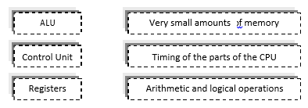

1. Match the units on the left to the their meaning on the right

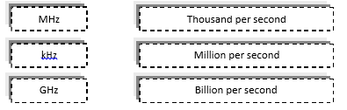

1. A processor states that it is dual core. How many cores does it have?

2 cores

1. For each description below name the part of the CPU that they describe
   1. A type of memory on the processor that stores only a few bytes of data for each one.

Cache memory

* 1. Responsible for arithmetic and logical operations

ALU unit

* 1. Needed to coordinate timing and data flow in the processor

Control unit

* 1. An intermediate type of memory between registers and RAM

Register memory

1. A dual core processor has a speed of 1.7GHz. How many operations can it carry out per second? 1.7GHz x 2 = 3.4HGz per second
2. Write out and complete the text below:
   1. A CPU will make use of very small areas of memory called registers which operate at the same speed as the processor. The CPU can also read from, and write to, RAM. This operates at a GHz speed. Processors can also contain cache memory. This operates at a speed that is faster than RAM. By increasing the amount of cache, a computer will work as it will have to make fewer accesses to RAM.
3. A CPU that contains more than one core is known as what type of processor?
4. What are the names given to CPUs with six cores? Eight cores?
5. Michael’s computer has a 2.2 Ghz dual-core processor with 2GB RAM and 200GB hard disk. It also has 512MB of Cache memory
   1. What is the purpose of the CPU?
   2. Why does the computer have both 512 MB cache memory and 2GB RAM
   3. What is meant by ‘dual-core’
   4. How will upgrading the computer’s RAM to 4GB improve the performance of the computer?